**EVALUATING THE ANTI-AMOEBIC POTENTIAL OF MALABARICONE AGAINST *NAEGLERIA FOWLERI* WITH INSIGHTS FROM IN SILICO ANALYSES**

Kavitha Rajendran1*, Lemmuel Tayo2,#a*, Marineil Gomez,3, #a, Devandran Apparasamy1, Haema Thevanayagam4, Regine Menente2,¶, Catherine Joyce Rueda2,¶, Yasodha Sivasothy5, Muhamad Aqmal Othman6, Usman Ahmed7, Ayaz Anwar7, Niwasini Krishna Kumar 1

**S1 Table. Docking results on the 3 binding sites in CB-DOCK2 and DINC**

|  |  |  |  |  |  |
| --- | --- | --- | --- | --- | --- |
| **Receptor** | **Binding Site** | **Malabaricone A** | **Malabaricone B** | **Malabaricone C** | **Amphotericin B** |
| **DINC** |  |  |  |  |  |
| NFCYP51 (7RKW) | **Site 1** | **-9.50** | **-9.50** | **-9.50** | **-8.70** |
| Site 2 | -7.30 | -7.40 | -7.60 | -7.80 |
| Site 3 | -6.00 | -6.40 | -6.50 | -8.20 |
| CB-Dock2 |  |  |  |  |  |
| NFCYP51 (7RKW) | **Site 1** | **-7.90** | **-7.80** | **-7.80** | **-5.60** |
| Site 2 | -6.80 | -6.90 | -7.30 | -8.30 |
| Site 3 | -6.20 | -6.60 | -6.70 | -7.20 |
| DINC |  |  |  |  |  |
| NFCYP51 (7RKT) | Site 1 | -7.80 | -7.80 | -7.40 | -9.40 |
| Site 2 | -7.00 | -7.40 | -7.50 | -8.80 |
| Site 3 | -5.90 | -6.80 | -6.60 | -9.80 |
| CB-Dock2 |  |  |  |  |  |
| NFCYP51 (7RKT) | Site 1 | -6.50 | -7.50 | -7.30 | -7.10 |
| Site 2 | -6.30 | -5.30 | -5.40 | -8.00 |
| Site 3 | -5.30 | -5.30 | -5.70 | -7.50 |
| DINC |  |  |  |  |  |
| Cathepsin B | Site 1 | -7.80 | -7.60 | -7.90 | -8.40 |
| Site 2 | -7.30 | -7.90 | -6.70 | -8.30 |
| Site 3 | -6.40 | -6.70 | -6.70 | -8.30 |
| CB-Dock2 |  |  |  |  |  |
| Cathepsin B | Site 1 | -5.70 | -5.60 | -5.80 | -7.30 |
|  | Site 2 | -5.40 | -5.70 | -5.90 | -7.70 |
|  | Site 3 | -5.30 | -6.20 | -5.90 | -7.50 |
| DINC |  |  |  |  |  |
| Serine Carboxypeptidase NF314 | **Site 1** | **-9.10** | **-9.30** | **-9.20** | **-7.50** |
| Site 2 | -6.70 | -7.10 | -7.10 | -8.90 |
| Site 3 | -6.50 | -6.60 | -6.50 | -8.60 |
| CB-Dock2 |  |  |  |  |  |
| Serine Carboxypeptidase NF314 | **Site 1** | **-7.80** | **-8.50** | **-7.80** | **-5.90** |
| Site 2 | -6.10 | -6.50 | -6.00 | -8.00 |
| Site 3 | -5.40 | -5.20 | -5.70 | -6.70 |
| DINC |  |  |  |  |  |
| Rab Family Small GTPase | **Site 1** | **-8.50** | **-8.40** | **-8.50** | **-7.60** |
| Site 2 | -7.10 | -6.90 | -6.60 | -8.60 |
| Site 3 | -6.40 | -6.50 | -6.20 | -8.20 |
| CB-Dock2 |  |  |  |  |  |
| Rab Family Small GTPase | **Site 1** | **-8.00** | **-8.00** | **-7.50** | **-6.20** |
| Site 2 | -5.40 | -4.80 | -6.00 | -8.40 |
| Site 3 | -5.10 | -5.70 | -5.70 | -7.00 |
|  |  |  |  |  |  |

**S2 Table** Protein-ligand binding site coordinates

|  |  |  |  |  |
| --- | --- | --- | --- | --- |
| Protein | PDB ID | UniProt ID | Binding Site Coordinates | |
| NFCYP51 | 7RKW | - | Site 1 | 16.0, -5.0, 16.0 |
| Site 2 | 11.0, 6.0, 30.0 |
| Site 3 | 20.0, 3.0, 8.0 |
| 7RKT | - | Site 1 | 12.0, 3.0, 30.0 |
| Site 2 | 4.0, 11.0, 13.0 |
| Site 3 | 24.0, 3.0, 8.0 |
| Cathepsin B | - | X5D761 | Site 1 | -14.0, 15.0, 10.0 |
| Site 2 | -10.0, 13.0, 12.0 |
| Site 3 | 7.0, 0.0, -23.0 |
| Serine Carboxypeptidase NF314 | - | P42661 | Site 1 | 18.0, 8.0, 1.0 |
| Site 2 | 2.0, 10.0, -1.0 |
| Site 3 | -2.0, 9.0, -21.0 |
| Rab Family Small GTPase | - | D2VS55 | Site 1 | 12.0, 8.0, -7.0 |
| Site 2 | -4.0, -9.0, 8.0 |
| Site 3 | 0.0, 4.0, 16.0 |

**S3 Table. Free binding energy, ΔGbind, of the complexes calculated using MM/PBSA and MM/GBSA from Gromacs MD simulation trajectories.**

|  |  |  |  |  |
| --- | --- | --- | --- | --- |
|  | **MM/GBSA in kJ/mol** | | **MM/PBSA in kJ/mol** | |
| **Complex** |  | **se** |  | **se** |
| CYP-MA | -30.616 ± 0.201 | 0.103 | 1.846 ± 0.383 | 0.195 |
| CYP-MB | -29.901 ± 0.263 | 0.134 | 11.569 ± 0.411 | 0.209 |
| CYP-MC | -31.018 ± 0.294 | 0.150 | 5.279 ± 0.480 | 0.245 |
| R-MA | -14.872 ± 0.356 | 0.181 | 4.288 ± 0.453 | 0.231 |
| R-MB | -27.288 ± 0.556 | 0.283 | **-3.263 ± 0.585** | **0.298** |
| R-MC | -19.764 ± 0.486 | 0.247 | 5.034 ± 0.770 | 0.392 |
| S-MA | -40.114 ± 0.476 | 0.242 | **-4.873 ± 0.967** | **0.492** |
| S-MB | -40.552 ± 0.441 | 0.225 | **-2.229 ± 0.596** | **0.303** |
| S-MC | -42.820 ± 0.408 | 0.208 | **-1.217 ± 0.531** | **0.270** |

Standard error, se; NFCYP51, CYP; serine carboxypeptidase Nf314, S; Rab family small GTPase, R; malabaricone A, MA; malabaricone B, MB; malabaricone C, MC.

aAt α=0.05

**S4 Figure. ΔGbind fluctuations during the simulations (left); distribution of ΔGbind values**

**S4 Figure, cont’d. ΔGbind fluctuations during the simulations (left); distribution of ΔGbind values**

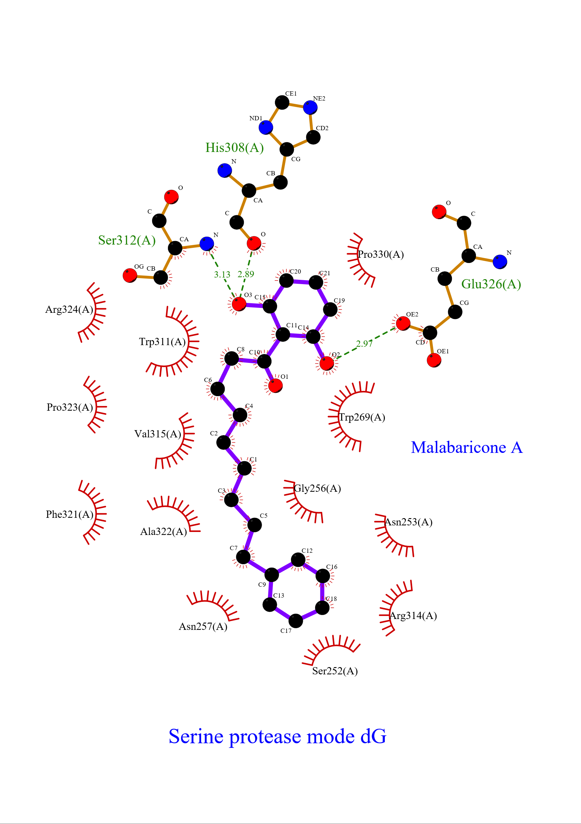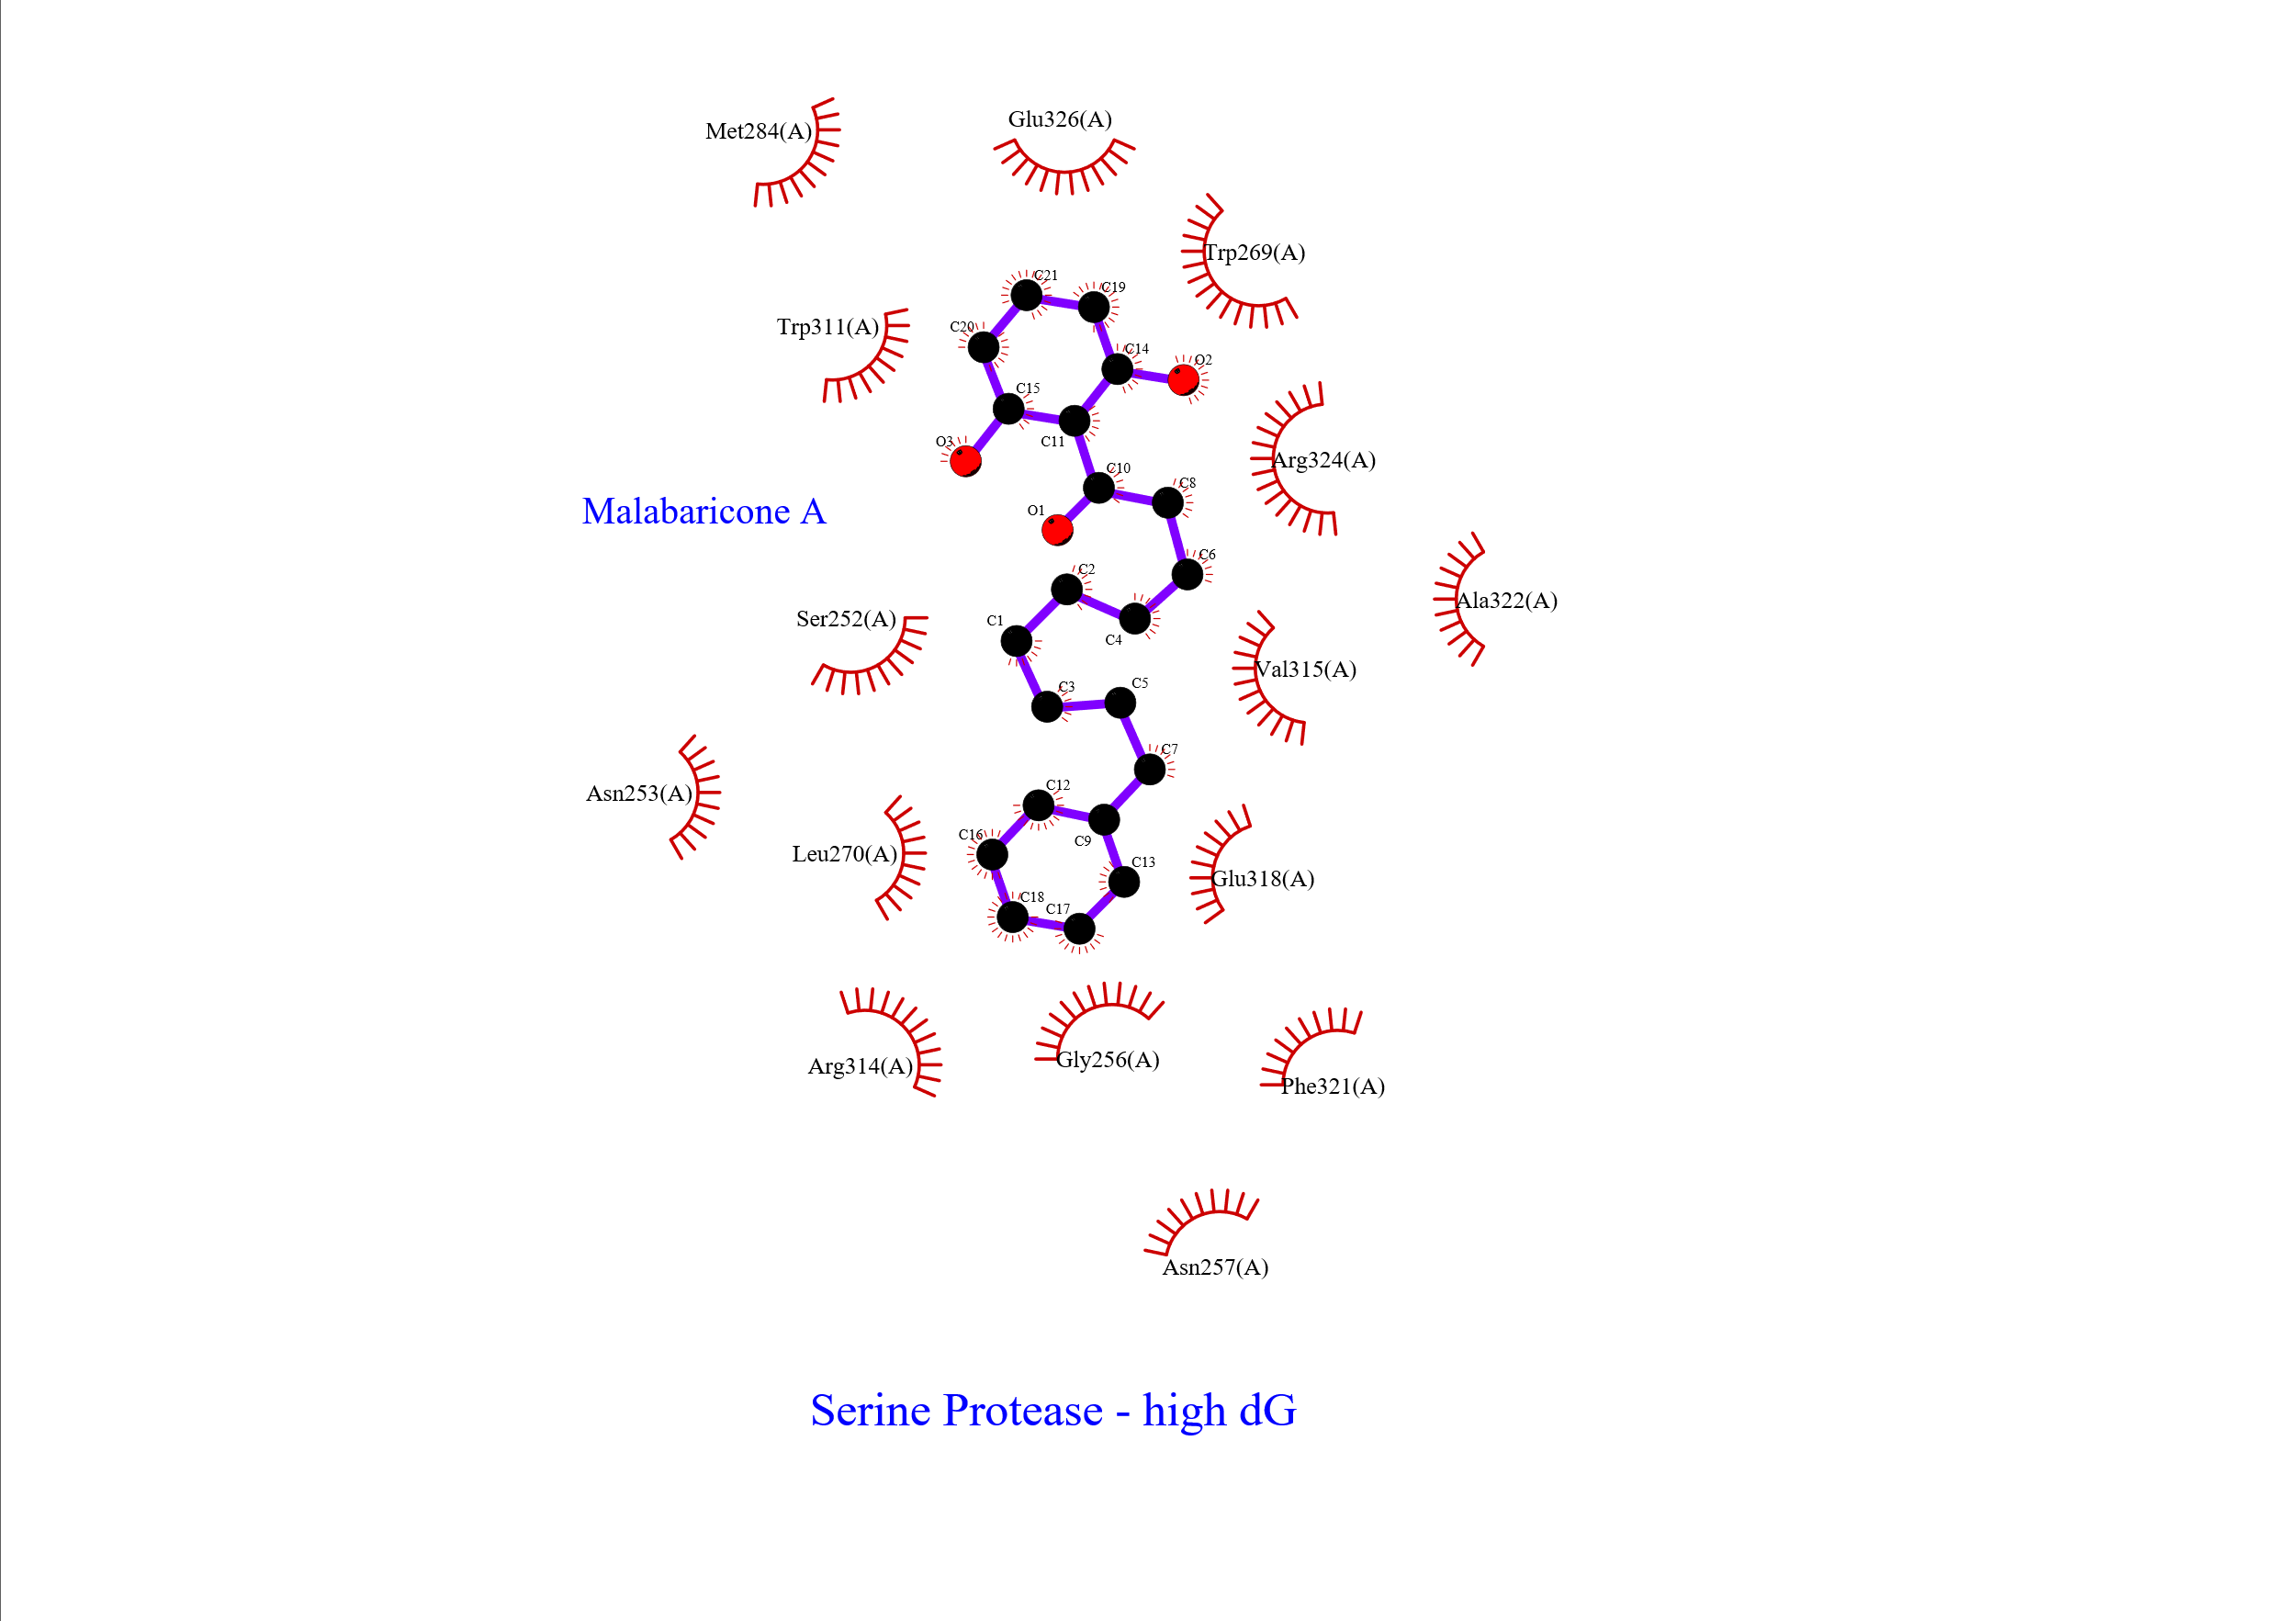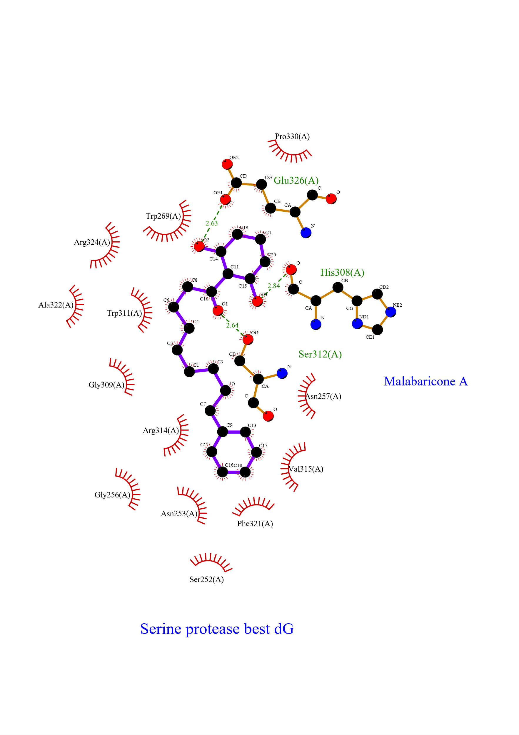

**S5 Figure. Intermolecular interactions of malabaricone A with serine carboxypeptidase visualized in 2D using LigPlot+**

**S6 Figure. Intermolecular interactions of malabaricone B with Rab Family GTPase visualized in 2D using LigPlot+**

**S7 Figure. Intermolecular interactions of malabaricone B with serine carboxypeptidase visualized in 2D using LigPlot+**

**S8 Figure. Intermolecular interactions of malabaricone C with serine carboxypeptidase visualized in 2D using LigPlot+**

**Table S4.** Summary of toxicity predictions for malabaricone A, B, C and amphotericin B using ADMETLab3.0, ProTox, and vnn-ADMET models.

|  |  |  |  |  |  |  |  |  |  |  |  |  |  |
| --- | --- | --- | --- | --- | --- | --- | --- | --- | --- | --- | --- | --- | --- |
|  |  | Malabaricone A | |  | Malabaricone B | |  | Malabaricone C | |  | Amphotericin B | |  |
|  |  | ADMETLab | ProTox | vnn-ADMET | ADMETLab | ProTox | vnn-ADMET | ADMETLab | ProTox | vnn-ADMET | ADMETLab | ProTox | vnn-ADMET |
| hERG blocker | <50% | 28% |  | No | 23% |  | No | 15% |  | No | 0% |  | Maybe not |
| Cardiotoxicity | <50% |  | active |  |  | active |  |  | active |  |  | active |  |
| Ames Toxicity | <50% | 23% |  | Maybe not | 23% |  | No | 29% |  | Maybe not | 56% |  | No |
| Mutagenicity | <50% |  | inactive |  |  | inactive |  |  | inactive |  |  | inactive |  |
| Carcinogenicity | <50% | 10% | inactive |  | 15% | inactive |  | 13% | inactive |  | 2% | inactive |  |
| ROA / cytotoxicity | <50% | 22% | inactive | Maybe not | 24% | inactive | Maybe not | 27% | inactive | Maybe not | <1% | inactive | Maybe not |
| Nephrotoxicity | <50% | 34% | Active, 61% |  | 23% | Active, 63% |  | 10% | Active, 61% |  | 100% | Active, 77% |  |
| Hepatotoxicity / DILI | <50% | 7% | inactive | Yes | 4% | inactive | maybe yes | 10% | inactive | No | 53% | inactive | No |
| Neurotoxicity | <50% | 16% | inactive |  | 14% | inactive |  | 2% | inactive |  | 0% | inactive |  |
| Respiratory irritation | <50% | 94% | inactive |  | 94% | active |  | 92% | inactive |  | 0% | active |  |